Cell Division

- Explain how cell division is used in:

  - Unicellular organisms
Unicellular organisms use mitosis to reproduce asexually, replicating themselves, such as in bacteria.
  - Multicellular organisms
Multicellular organisms use mitosis for growth, repair of damaged less and to replace lost cells.

- Diagram 1 shows the nucleus of a body cell as it begins to divide by mitosis.

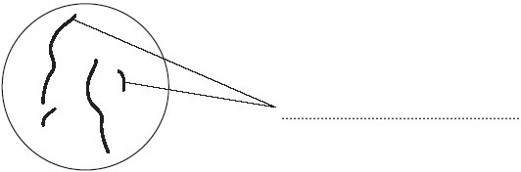
chromosomes
Diagram 1
- Use a word from the box to label Diagram 1.

alleles chromosomes gametes

b. Complete Diagram 2 to show what the nucleus of one of the cells produced by this mitosis would look like.
Diagram 2

(Identical to diagram 1 – same number of chromosomes)

- Order the following statements to show the order of events during the cell cycle.

- Two new identical daughter cells are produced
- The cytoplasm and cell membrane divides
- The chromosomes are pulled apart to separate ends of the cell
- The cell grows and doubles its sub-cellular structures and replicates its DNA
- The chromosomes line up along the centre of the cell before being pulled by spindle fibres

Order:
__D_____ → ___E__ → ___C____ → ___B____ → ___A____

- Explain why the DNA and sub-cellular structures must be replicated before the cell divides.
This is so that when the cell divides each new cell has the same number of chromosomes/amount of DNA/enough organelles as the original cell. If this did not happen then each new cell would only have half the required amount.
- Explain why mitosis may happen more frequently in young organisms than mature ones.
Mitosis is needed in young organisms as it allows organisms to grow. Mature organisms have stopped growing but they still need some mitosis to repair damaged cells or replace lost ones, but this is not as frequent as during the growth process.

Stretch Activity:
There are two types of cell division – mitosis and meiosis. Mitosis is used for growth, repair and asexual reproduction. Meiosis is used for the production of sex cells. Suggest how the process of meiosis is different to mitosis, considering their different outcomes.
- Mitosis produces daughter cells that are identical but in meiosis, gametes are made that must have half the number of chromosomes
- Therefore the process of meiosis must include an extra division process as compared to mitosis

